
FACULTY OF TECHNOLOGY AND ENGINEERING
DEVANG PATEL INSTITUTE OF ADVANCE TECHNOLOGY
AND RESEARCH
DEPARTMENT OF COMPUTER ENGINEERING
A.Y 2026 – 27 Semester – 3
LAB MANUAL

CSUC201 Fundamentals of Data Structures and Algorithms


Practical 1: Array Operations: Traversal, Rotation, and
Frequency Analysis
Practical Aim
Problem 1
A bakery prepares n items every morning and places them in a display row. At the end of each hour, the leftmost item is moved to the rightmost position to make room for fresh stock at the front. Given the initial row and the number of hours h, print the final display order. Describe the approach you used. How does it behave when h is very large, say 10 million? Is there a way to get the correct result without performing the operation h times?
Code:
Github link:
https://github.com/25DCS032/DSA-25dcs032
Output screenshot:

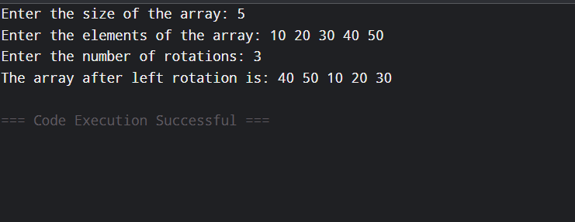
Problem 2
A library issues books to students and records each book's ID every time it is borrowed. At the end of the month, the librarian wants to find all books that were borrowed more than once, as those need priority restocking. Given the borrowing log, print all such book IDs.Describe the approach you used. How many times does your solution scan the data? If thelibrary had 100,000 borrow records, would your approach still be practical? Can you think of a way that requires fewer passes?
Code:
Github link:
25dce103_DSA_PJP_3CE2_B/practical-1 at main · nidhisavalia/25dce103_DSA_PJP_3CE2_B

Output screenshot:
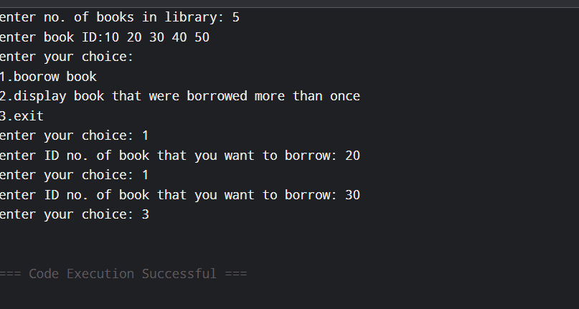 Problem 3
A school newspaper editor wants to highlight the most impressive word from a submitted article on the front page. The word is chosen simply by length — the longest one wins. Given a sentence, print the winning word and how many letters it has.Describe the approach you used. What does your solution do when two words have the same length? Is that behavior intentional, and can you think of a way to handle it explicitly?
Code:
Github link:
25dce103_DSA_PJP_3CE2_B/practical-1 at main · nidhisavalia/25dce103_DSA_PJP_3CE2_B
Output screenshot:
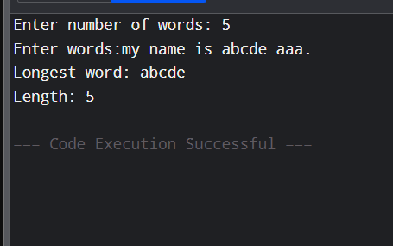
Problem faced:
Counting duplicate book IDs correctly.
Finding the longest word in a sentence
Out come:
Understanding how array rotation works.
how to find duplicate elements using frequency counting.

Key Questions / Analysis / Interpretation to be Evaluated During/After
Implementation
1.The display order repeats itself after a certain number of hours regardless of
how large h gets. Without trying any specific example, explain why this repetition is
inevitable and what determines when it first repeats.
Ans. The display repeats because moving the first item to the end is a rotation. After n rotations, the original order comes back. So, repetition is determined by the number of items n.
2. If the same book ID appears three times in the log, should it appear once or
three times in your output? Does your solution handle this correctly, and how would you
verify it?
Ans: If a book ID appears three times, it should be printed only once because we need to find IDs borrowed more than once. We can verify it by checking the frequency of each ID.
3. The editor later decides that punctuation attached to a word (e.g. “hello,” or
“great!”) should not count toward its length. How would this change your solution, and at which step would you handle it?
Ans. Punctuation should be removed or ignored before calculating the word length. For example, hello, is treated as hello, so its length is 5.

